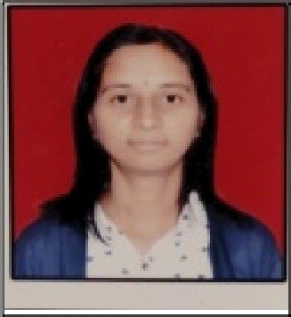Resume

**Minakshi Tiwari Address:**

Lasur Station ,Tq-Gangapur , Dist-sambhajinagar Contact No.: 9175358583

**Email id:** minakshitiwari24l tâ'gmail com

* Secure a responsible career opportunity to fully utilize my talent and skills to grow, while making a significant contribution to the success of the company.

|  |  |  |  |  |
| --- | --- | --- | --- | --- |
| **ExsmNmoe** | Board f University | **Pasaiog yesr** | **Percentage uf Msrks** | **Division** |
| High Schuul | Maharashtra Board | 20 IN | f›5.Bf1 & | First |
| **intermediaie** | Dr Babasaheb Ambeilkar Marathwada | 2fl19 |  |  |
| Bachelcir of ccunputer Application | Dr Bahasaheb Amhedkar |  | 72. 17 | First |

* Basic Knowledge of Computer

Date of Birth Father's Name Mother's Name Nationality Gender

Marital Status

Language Hobbies

**Declaration:**

50-01-2001

Rajendra Tiwari Sheela Tiwari Indian

Female Unmarried

English,Hindi,Marathi

Reading books, Listening music,Cooking,

I hereby declare that all the statement made in this resume are true, complete and *co*rr*ect* to

the Knowledge.

1